**CUSTOM THEME**

The theme of a website has much more influence than you might think. After all, the theme is not only the site's color or typography. Additionally, it's about brand awareness and user experience. It is often the reason people stay longer on your site and become clients.

**Requirements:**

1. **Theme_name.info.yml**

**Theme_name.info.yml** is the most critical part of this process. This file contains all metadata, libraries, block regions, and other necessary information.

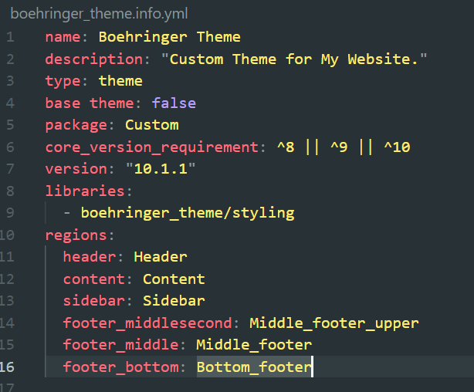

1. **Theme_name.libraries.yml**

**Theme_name.libraries.yml** file to specify and place the libraries you need for your site to function correctly. There will be CSS and JS. We name the library styling.

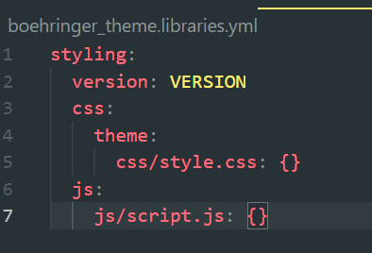

1. **Css file**

We should apply CSS styles for each region based on your design. style.css should include CSS according to your requirements.

1. **Js file**
2. **Html.twig file**

we must include new region settings on the html.twigfile if you have set up regions for our theme.

1. **Appearance** → **Install new theme.**

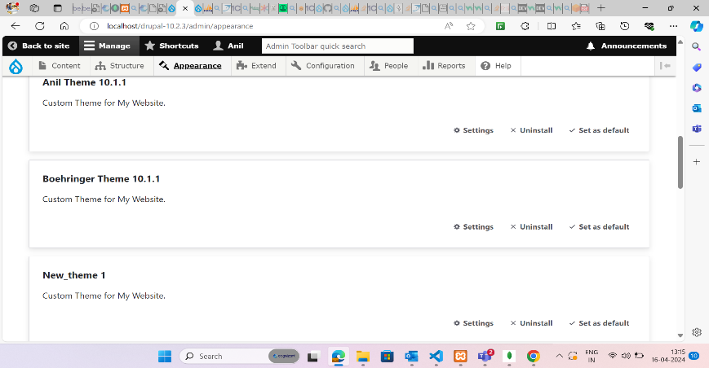

1. **After installing the theme**

1. **Block Layout**

1. **Home front page(UI view)**

